Java Apps Final Project Spec

The goal of this project is to create a User Interface for the Periodic Table that is neat, informative, and reliable. In order to accomplish this, I need to determine my class hierarchy, plan out my user interface, and plan my implementation.

For class hierarchy, I will have one Parent class called “Element”. There will be nine sub classes that will inherit from the Element class. These subclasses will be for the nine different element groups in the periodic table: AlkiliMetal, AlkilineEarth, TransitionMetal, BasicMetal, SemiMetal, NonMetal, Halogen, NobleGas, RareEarth. Each element object will have a name, molecular weight, atomic number, and charge (depending on the type of element). The methods for the elements will be simple getter and setter functions for the data fields. Although each subclass has similar data fields and behaviors, it will be important to keep track of what subclass each element is an instance of. There will also be a Main class to control to the User Interface.

For the User Interface, the first thing that will appear will be a Periodic Table on a Grid Layout. The Grid boxes will be the same size as the Periodic Table element boxes, so each element will be in its own box. Also, each element will be a button that the user can click on to receive the information on that specific element. In order to make all the element types distinct, different buttons will be different colors based on the type of element. In addition to this, there will be a search bar in which the user can search for a specific element and get its information.

The names, molecular weights, and atomic numbers of all the elements will be read from a text file and used to construct all the element objects. In order to make the interface, there will be a frame with a panel that will have a grid layout. There will be a button created for each element and these buttons will be arranged like the periodic table in the grid layout. Each button will have its corresponding element associated with that button. Also, each button will implement ActionListener to open up a new JFrame that will display text that is the information on the element that was just clicked on. Lastly, there will be a search bar in the top right corner of the frame that has the periodic table.

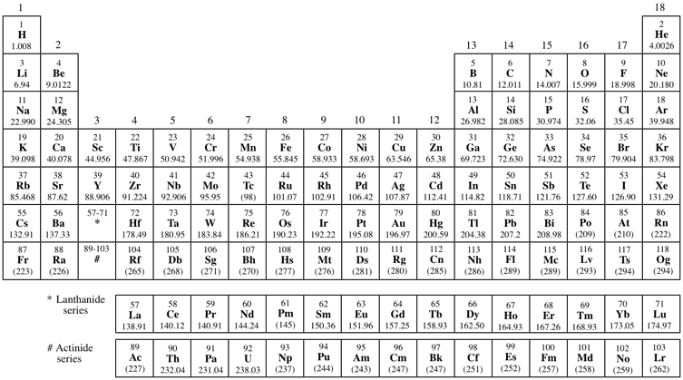

| Element |
| --- |
| * String Name * double molecularWeight * int atomicNumber |
| * Element(String name, double molecularWeight, int atomicNumber) * double getWeight() * int getAtomicNumber() |

| AlkiliMetal (Inherits from Element) |
| --- |
| * AlkiliMetal (String name, double molecularWeight, int atomicNumber) |

| AlkilineEarth (Inherits from Element) |
| --- |
| * AlkilineEarth (String name, double molecularWeight, int atomicNumber) |

| TransitionMetal (Inherits from Element) |
| --- |
| * TransitionMetal (String name, double molecularWeight, int atomicNumber) |

| BasicMetal (Inherits from Element) |
| --- |
| * BasicMetal (String name, double molecularWeight, int atomicNumber) |

| NonMetal (Inherits from Element) |
| --- |
| * NonMetal (String name, double molecularWeight, int atomicNumber) |

| SemiMetal (Inherits from Element) |
| --- |
| * SemiMetal (String name, double molecularWeight, int atomicNumber) |

| Halogen (Inherits from Element) |
| --- |
| * Halogen (String name, double molecularWeight, int atomicNumber) |

| NobleGas (Inherits from Element) |
| --- |
| * NobleGas (String name, double molecularWeight, int atomicNumber) |

| RareEarth (Inherits from Element) |
| --- |
| * RareEarth (String name, double molecularWeight, int atomicNumber) |